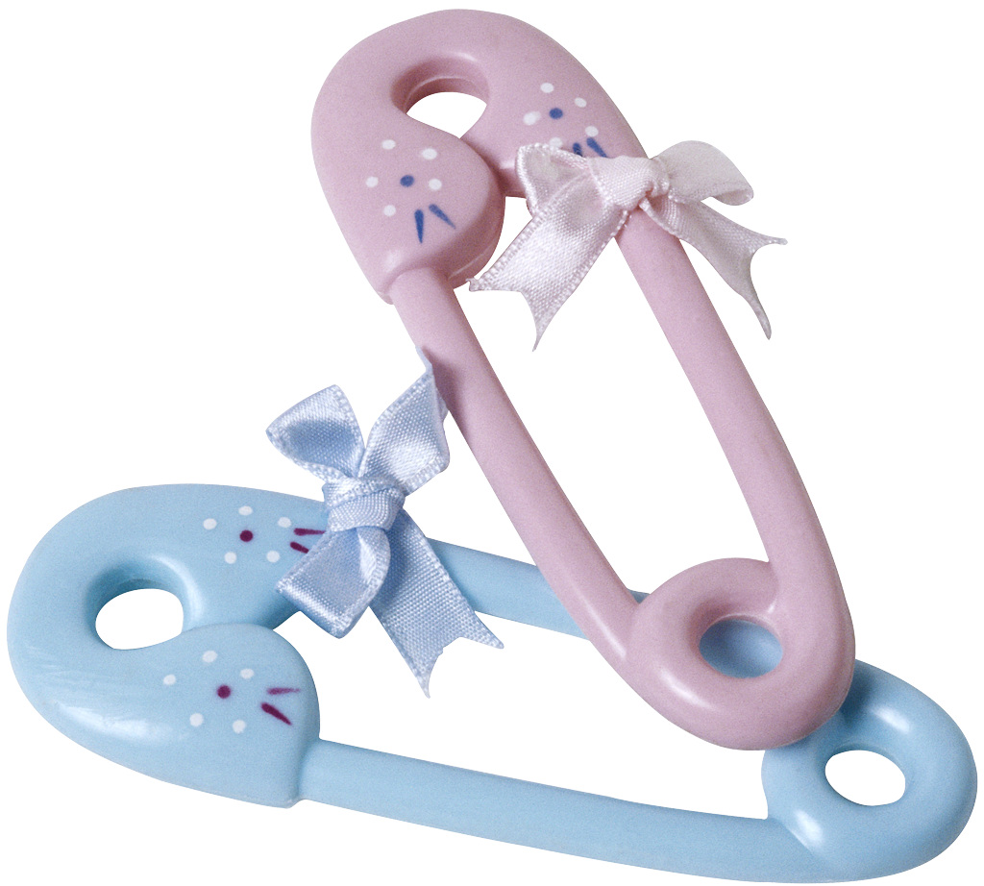

Acupuncture treatment for fertility
Acupuncture and herbs have been used for years to treat many gynecological conditions. Acupuncture can improved ovarian and follicular function as well as increasing blood flows to the endometrium, helping to facilitate a thick, rich lining.

Length of treatment for fertility
Patients may be treated for two to six months before considering natural conception or assisted reproductive technology. Typically, about one to two treatments per week is required to have a therapeutic effect before progressing to insemination, in vitro fertilization (IVF), or donor-egg transfer.

Acupuncture protocol for IVF
In a study by Stener-Victorin et al from the Departments of Obstetrics and Gynecology Fertility Centre, Scandinavia and University of Gothenburg, women are encouraged to receive acupuncture treatments pre and post embryo transfer.

Common conditions treated with acupuncture
- Repeated pregnancy loss/miscarriages
- Luteal phase defect
- Hyperprolactinemia
- Polycystic ovarian syndrome
- Endometriosis
- Male infertility factors

